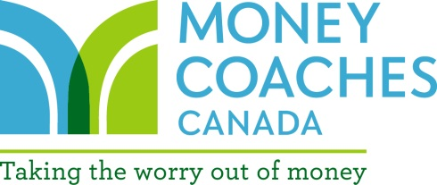
Your Investment Check-Up
What you need to know about your investments and how they are managed

- Is your current advisor meeting your expectations?
- What is your knowledge and desired level of involvement in managing your investments?
- Do you have a good understanding of what you are invested in and why?
- Is your investment statement easy for you to read and understand?
- Have you and your advisor developed a clear plan of how much you should have invested in cash, bonds and stocks based on your goals for each of your investment accounts?
- What percentage of your investments are currently held in cash, bonds and stocks?
- What rate of return have you earned on your investments over the last year, 3 years, 5 years, 10 years and since you started to invest with your advisor?
- How do the returns on your investments compare to the market in general? Compare the rate of return of your investments to the relevant market index. (eg. compare your Canadian equity mutual fund to the S&P TSX index, compare your US mutual fund to the S&P 500, etc)
- What fees are you paying for investment management?
- Do you have “load” mutual funds with a deferred sales charge (DSC) – ie. is there a redemption charge if you transfer out of your current funds?
- Do you know how your advisor is compensated?
- How often do you meet/speak with your advisor? How often would you like to meet/speak with your advisor? (a minimum of one formal in-person meeting a year is recommended)
- How much contact outside the meetings do you have with your advisor or advisor’s assistant?
- Does your advisor listen to your needs/goals and educate you on investing concepts?
If you don’t have the answers to the above questions or if you aren’t satisfied with the service you are receiving, book a meeting with your current advisor to review the above. If you aren’t satisfied with the answers, it may be time to look for a different advisor. (If you are your own advisor, make sure you can answer these questions as well!)

